Programming Assignment #2

**Programmer:** Timothy Vicars

**Course:** CSCI 3352

**Date:** Nov 11, 2019

**Programming Assignment:** #2 – B-Tree Insertion and traversal

**Environment:** Microsoft Windows Visual C++, Linux GCC C++

**Objective:** This programming assignment was to implement B-Tree algorithms

**Algorithm:**

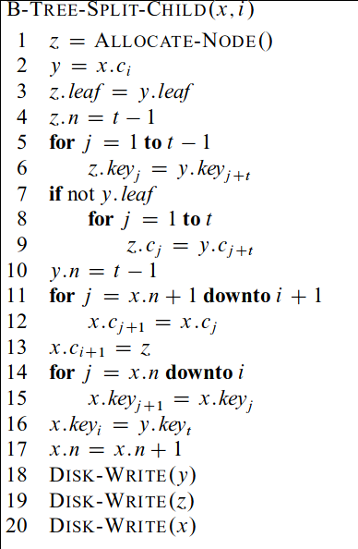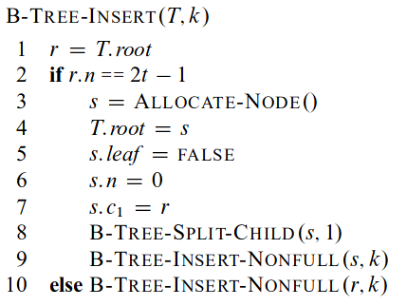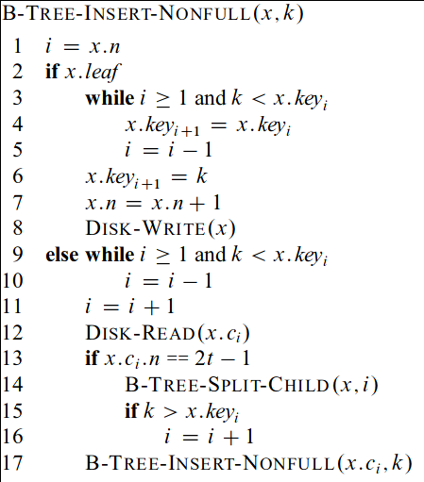

**Input**: series of integers

**Output**: a sorted series of numbers

**Compile:** (Linux):

$ g++ -o btree btree.cpp

$ g++ -o btree btree.cpp

**Run**: $ ./btree

